Play Based Learning Experiences (PBLE) Plan Guidelines
Fall 2020

DAP Check |  | Description and Expectations
Anecdotal documentation; objectively describe what you are seeing the child(ren) do and say |  | Description: Before building an intentional activity, you should always start with observation and understanding what children are able to do.  Expectation: Write in DETAIL what you have observed the child(ren) do and/or say. Be objective in your description. Pay attention to small details and try and capture those ideas.
Brainstorm which skills/concepts are children working on in this experience? (List all that you see) |  | Description: It is important to reflect on the skills and concepts that children were demonstrating through the documentation above.  Expectation: Identify all skills/concepts that you see children engaging in during this observation. This may go across multiple domains of development…brainstorm all that you can think of.
Pick the most prominent skills/concepts you noticed or want to focus on | Skill/Concept:  Why did you pick this skill/concept?: | Description: After you have brainstormed all the skills, we need to narrow it down to one area of focus. An intentional teacher does not plan for everything, they plan to focus on one area to become more involved in that concept.  Expectation: Identify 1 skill/concept that you plan to focus on for your upcoming experience with children. Also, explain why you felt this was the best skill to focus on.
What does this child(ren) know based on what you observed (strength)? |  | Description: When teaching, we want to focus on what children are already capable of doing so we are thinking of children from a strengths-based perspective.  Expectation: Describe what you have noticed about the child(ren) in this one skill in regards to what strengths they will already come to you in your planned experience based on what you have already observed
What is the child(ren) developing based on what you observed (growth)? |  | Description: When teaching, we want to focus on what children are already capable of doing so we are thinking of children from a strengths-based perspective.  Describe what you have noticed about the child(ren) in this one skill in regards to what strengths they will already come to you in your planned experience based on what you have already observed
Foundations that you reference to determine skills/concepts children are developing | Domain:  Strand:  Substrand:  Foundation:  Domain:  Strand:  Substrand:  Foundation: | Description: Once you have observed the children to identify interests, skills, abilities, development, and personal experiences; the Foundations should direct you into determining which skills the children should be working towards based on age level and what is developmentally appropriate for children in early childhood.  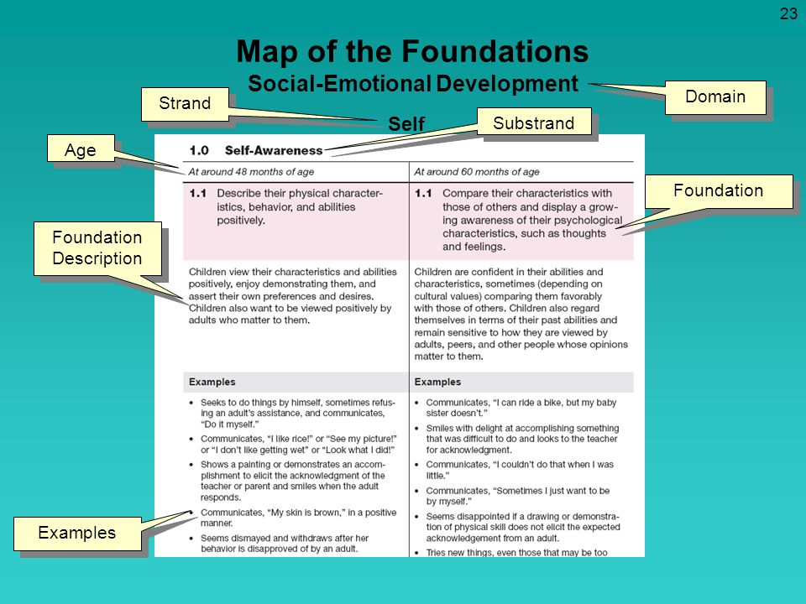  Expectation: Use the map above to identify the components of the Foundations that should be documented. There should be at least 2 Foundations identified and all sections appropriately documented using that map. If there is a number, such as 2.0 or 2.1, include those in your plan. NOTE: If you are in the Sea Dragon class, you do not need to put the substrand because you should be using the Infant/Toddler Foundations.
Describe the activity that you will be planning as the next step for the children’s development. |  | Description: This section is to give you the opportunity to easily describe what your activity is. It is a brief statement that explains to anyone what children will be doing in your free choice experience.  Expectation: Write 2-4 sentences to identify what the actual activity is (ex. Children will be finger painting with glitter finger paint).
Objectives | At the end of this experience, children will be able to…  At the end of this experience, children will be able to… | Description: Objectives are simple statements that help you to be more intentional in your focus of the Concept/Big Idea you have planned. These should be statements that hone in on the specific skills or abilities you are focusing on or expecting children to accomplish in the experience. Objectives should be S.M.A.R.T. meaning that they are:  - Specific – Specific to children’s interests, abilities, skills, development  - Measurable – I can easily see or observe the children demonstrate the skills you are looking for.  - Attainable – The skills are something that children are able to accomplish due to skills and abilities.  - Relevant – The experience is relevant to children’s development and/or their lives.  - Timely – That it is planned due to children’s current interests and abilities and not something that was interesting to them weeks/months ago. Be mindful to NOT plan seasonal experiences without considering the children’s relevant experiences in relation to seasons (ex. In Ventura, we will probably not discuss snow).  Expectation: Write 2 objectives to identify specific skills children will be developing in your experience based on your big idea/concept. Then, identify which are the components of SMART goals that you have included in your objectives. Check the appropriate boxes.  Tip: Look at your Foundations and if they are something that you could easily see children do, use those as an objective. If you couldn’t easily see children do the skill, then determine if it can be rewritten to be something you could see?
Frameworks that will guide my teaching | Guiding Principles:  Environment and Materials:  Interactions: | Description: The Frameworks are principles that help you to think about being intentional in your implementation of this experience when you interact with the children.  Expectations: Guiding Principles are listed first in every chapter of the Foundations. Identify 1 key idea in the Guiding Principle section that matches the experience you are planning. The Environment and Materials follows the Guiding Principles to help you think about how you will use the environment to help teach this concept. Pick one key idea in Environment and Materials to support your experience. NOTE: Guiding Principles and Environments and Materials are broad key ideas for the entire Domain (ex. Visual Arts will all have the same Guiding Principles and Environments and Materials to choose from.)  Interactions and Strategies are more specific to the Foundations that you have chosen. You have to move further into the Domain to identify Interactions and Strategies. For example, If you chose a Foundation that is a 2.0, you will need to look for Interactions and Strategies that are in 2.0 section. Once you have found a relevant Interactions and Strategy, document that AND then note which corresponding Foundation that matches.
DRDP Measure that relates to area of focus  Plan for when you will observe/document | DRDP Measure:  Definition:  Plan for documentation: | Description: The DRDP 2015 is the assessment tool used to measure children’s development. The different Measures of the tool help you to think about how you would assess the children’s development in relation to the experience you have planned.  Expectation: Identify at least 1 DRDP measure that would measure the children’s skills within this activity. Write out the measure title including the number and then include the definition. Also, for the plan to document, identify when you will document during your activity while you are implementing and how you plan to document multiple children within the same activity.
Real life experience/relevance check |  | Description: In order for children to connect with their learning, it is best to create experiences that have a real-life connection to children. This can be through their own life experiences, creating a hands-on learning opportunity that they can engage through concrete play, or that is relevance for their life.  Expectations: Discuss how your planned experience will connect to children’s real life experiences, be concrete for the child’s learning the concept you are teaching, or is relevant to the children at this time.
Adaptations for Equity | Pick 1:  ☐ Gender ☐ Special Needs ☐ English Language Learner  ☐ Culture/Ethnicity ☐ Family Lifestyle ☐ Economics  Plan for Adaptation: | Description: Adaptations for Equity help us to be mindful teachers in regards to special considerations for all children to be successful in your experience. This is a check to reflect on how you plan to be responsive to the needs of children in your group?  Expectation: Check off at least 1 equity area to plan for and then come up with how your activity will be adapted to meet the needs of the children through that equity lens. Make sure you include any additional materials you would need to adapt the experience in your materials list.
Differentiation of Learning Experiences |  | Description: Children who participate in your experience will have different skill levels and abilities. As an intentional teacher, we need to plan for all children’s capabilities.  Expectation: You should come up with a strategy or adaptation you will implement for children with lesser or more advanced skill levels. Make sure you include any additional materials you would need to adapt the experience in your materials list.  Tip: Look at the Foundations. There are 2 age levels listed in each Foundation. If you are planning for the younger children, the differentiated learning may be planning for the older children within the same skillset.
Preparation
Materials |  | Description: This section has you plan ALL of the materials you will use in your experience. Think of this section as if you were writing a shopping list.  Expectation: Identify ALL materials used within your activity. Be specific to the amount, color, type of materials you will use. Include materials that you are planning for differentiated learning and adaptation for equity.
Set Up of Space | Describe preparation:  Drawing of Environment: | Description: This section helps you to plan out how you will set up and use the space that you will be working in. This considers how you will actually set up the space for each of the children you have in the experience at one time. For example, if you have planned for 4 children, this section should demonstrate how you would set it up for 4 children.  Expectation: Write a step by step description of how you will set up the space AND draw how the environment will be set up.  Grading Note: You will not be graded on your drawing ability. Rather, you will be graded on the clarity of your plan
Safety concern(s) AND solutions: |  | Description of Potential Safety Concerns: During an activity, there is always a possibility of a safety concern, whether it is slipping on the sensory material or something more extreme. This should consider how children will be potentially hurt due to the use of materials. For example,  Expectation: Come up with at least 1 safety concern and how you plan to prevent it from happening.
Intentional Teaching
Intentional Teaching | Research about this Concept:  Open-Ended Questions/Conversation Starters about concept taught:  1.  2.  3.  Vocabulary: (List at least 3 vocabulary words that will be introduced and definition/explanations | Description for Research As a teacher, what do you need to know about the concept you are teaching. In order to teach this concept, what do YOU need to know to be a successful and prepared teacher to be able to have conversations with children about the concepts? What do YOU need to learn about to be able to teach this concept? This is about the actual content/objectives/concept you are teaching to and not necessarily to the materials you are using, unless that is relevant to the content. For example, if you are counting with children using ice cream erasers and a dice, we should see research about children’s counting skills, possibly effective methods to teach counting, but not about ice cream.  Expectation: There should be at least 2 website addresses or resource books that you have found information on the concept that you will be teaching. Not only list the name of the books AND page numbers OR the website addresses, but also write out the content that you have learned about the content area that would be relevant to bring up to children through the experience.  Description of Open-Ended Questions/Conversation Starters: These are questions that require children to use more than a 1 word answer and put together language that helps them to think about the concept that you are planning on teaching. When it comes to your questions, consider the following:  - Is this what you really want to know based on the concept you are teaching?  - Is it something relevant to the child’s development?  - Is it something that is easily answerable?  - Is it something that has children recall a fact?  Expectation: There should be at least 3 identified open-ended questions listed related to your concepts/topics to either spark a conversation or to ask a question about how or what the child is gaining from their learning in the experience.  Tip: Ask yourself these questions. Can you answer it with a 1-2-word response or a simple yes/no response? If so, they are closed-ended question.  Description of Vocabulary: This section helps you to be intentional in the vocabulary you are going to introduce within this experience. These should be words that children may not be exposed to on a regular basis and supports the learning of the concept you are teaching.  Expectation: There should be at least 5 words identified that are based on experience. Then, there should a definition should be included and also a statement or sentence in how you would actually incorporate the vocabulary with children.
   | Vocabulary | Definition/Explanation for Children
  1
  2
  3
Behavior Management | Concern (Behavioral…not skill or safety based):  Prevention/Management Strategies: | Description: Within your activity, what might be an inappropriate behavior children might engage? Behaviors only…. NOT skills focused or inability to understand concepts or anything related to safety concerns. Instead, these are behaviors that may be perceived as “misbehavior”.  Expectation: You are to come up with at least 1 behavioral concern AND how you plan to prevent or manage the behavior.
Implementation
Plan for inviting children to engage in your activity (children are playing in centers…how will you invite them over to join you in your experience?) |  | Description: When children are playing in centers/free play, how would you encourage children to join you in your activity and leave what they are currently working on. This section helps you to plan your creative invitation to come and engage with you in your experience even though they may be engaging in other areas.  Expectation: Write out your language you plan on using…think of it as a script. This should be a creative invitation…NOT “want to come and do art with me?” Also, if you plan on using materials to entice children, list the materials you will use. Consider the materials you take to be 1 or 2 items…not all of your materials. Taking a model that you created is not acceptable.  NOTE: This should be planned for children who are engaging in centers/free play and NOT an introduction of your activity at a group time.  Grading Note: Be creative with what you would say to children…don’t just ask them to come to the activity.
What children will do in your activity (describe step by step from beginning to end) | From start to finish describe what children will do:  What you will look for (how you will see children meet your objectives): | Description: This section helps you to envision what children will be doing from the minute they sit down until they are done with the activity. This should be considered from their perspective, not yours as a teacher…think about what they will have control over within the experience.  Expectation: List a step by step description of what children will be doing in this activity from the moment they agree to come to your activity until they are finished and move to the next activity. Then, describe how you will see children demonstrate the objectives you have written while they are engaging in the experience.  Tip: Refer to the objectives page and re-write your objectives in language that demonstrates what children will actually do to achieve those objectives.
Reset/Clean up | Reset:  Clean Up: | Description: Reset is how you will prepare your stations for the next child after the last child is finished…think eating at a restaurant…you don’t sit down in the spot of the person before you with their dishes still on the table. Clean-up is how you will clean up at the end of your implementation including cleaning materials and putting them away. .  Expectation: Be specific in how YOU will reset the activity and how YOU will clean up the activity.
Closure and Transition |  | Description: The closure of an activity is how you will help children transition from their completion of the experience into the next experience. It should include:  1. A positive, specific summary of the learning experience given by you to the child or by the child themselves (DO NOT use general phrases such as “good job”.)  2. Transition for the child to the next activity.  Expectation: Include in a script form what you specifically will say to the child in a positive statement and the transition.
Family Connection | Mode (how you will communicate with families; newsletter, parent board, etc.):  Content (what you would actually say to families to explain what your activity was and how it affects child development):  When your child engages in….  They learn…  Suggested home extension (provide an example of how families can extend the learning at home):  At home you could…. | Description: This section helps you plan to communicate your experience to the families about why this experience was appropriate for their children’s development. How will you initiate and educate parents’ understanding the connection between children’s experiences and their learning with this activity?  Expectation: Identify the mode of how you will communicate to parents (ex. Newsletter, parent board) as well as the content of what you will say to parents why this experience was important for children’s development in a short succinct  description.  Then come up with an extension activity families could easily do at home to help continue to build this skill. Do not plan for families to have to purchase materials…think about what they may have around the house to support their children’s development with the skill you are teaching.

